Name: _____________________________________________________ Date: _________________ Period: _______
Lesson 1.1.4 Problems 1-35 to 1-39
1-35. Read the Math Notes box for this lesson and review the information about how to find the median of a data set. Then find the median for Andy’s test scores: 76, 84, 93, 67, 82, 87, and 76.

1-36. Use the fact that there are 12 inches in a foot to answer the questions below.
a. How many inches tall is a 7-foot basketball player?

b. If a yard is 3 feet long, how many inches are in a yard?

1-37. As you can tell from the examples of the number lines below, not all number lines change by one unit from mark to mark. Copy these number lines onto your paper and fill in the missing numbers.
a. 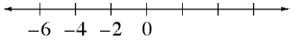 b.

c. d. 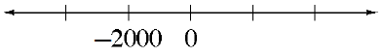

1-38. At the farmers’ market, two pounds of peaches cost $4.20. How much will five pounds cost? Show all of your work or explain your reasoning.

1-39. Janice’s mother gave her a ten dollar bill to buy five pounds each of bananas and apples at the grocery store. When she got there, she found that bananas were 80¢ per pound and apples were $1.40 per pound.
Did Janice’s mother give her enough money? If so, should she receive any change? If not, how much more money does she need? Show all of your work.

